Minor Project - 2
Zero Trust Architecture for Enterprise Security

1. Introduction -
Modern enterprise environments can no longer rely on traditional perimeter-based security models where internal network traffic is inherently trusted. This project demonstrates the practical application of Zero Trust Architecture (ZTA) within an enterprise security environment. Guided by the fundamental operational principle—"Never Trust, Always Verify"—this lab explores identity verification, Role-Based Access Control (RBAC), and micro-segmentation to prevent unauthorized lateral movement and enforce data confidentiality.

2. Authentication Models & Identity Verification
Multi-Factor Authentication (MFA)
Zero Trust requires strict identity verification before granting network access. MFA serves as the primary barrier against credential theft by requiring two or more verification factors:
- Something you know: - Password or PIN.
- Something you have: - Authenticator app, security key, or OTP.
- Something you are: - Biometric verification (fingerprint or facial recognition).
Role-Based Access Control (RBAC) & IAM
Identity and Access Management (IAM) systems enforce access rules according to defined organizational roles rather than granting blanket permissions:
- Principle of Least Privilege (PoLP): - Users are assigned only the minimum level of access necessary to perform their explicit duties.
- Dynamic Access Control: - Access is re-evaluated dynamically based on user identity, device health, location, and resource sensitivity.

3. Zero Trust Framework Architecture
The architectural framework implemented in this lab incorporates three core defense pillars:
IDENTITY & ACCESS MANAGEMENT
(MFA Verification & Role-Based Access Control)

MICRO-SEGMENTATION
Zone 1: HR Records | Zone 2: Finance Records
Permissions: 700 | Permissions: 000

THREAT ENFORCEMENT
(Authorized Access Allowed | Unauthorized Access Blocked)

- Identity Verification: Authenticating access attempts before allowing interaction with files or directories.

- Micro-Segmentation: Partitioning enterprise data into isolated, highly restricted zones (/company_data/hr_records and /company_data/finance_records).

- Encryption & Data Isolation: Applying file-level permission boundaries (chmod 700 and chmod 000) to guarantee that sensitive data remains encrypted or unreadable to non-authorized entities.

4. Environment Simulation & Policy Implementation
To simulate an isolated enterprise environment, a lightweight virtualized Linux terminal container environment was utilized. Inside this environment, isolated departmental zones were configured, populated with mock enterprise data, and secured using permission policies.
Execution Commands: -
- Creating Micro-Segmented Directories:
Bash
mkdir -p /company_data/hr_records
mkdir -p /company_data/finance_records
- Populating Enterprise Records: -
Bash
echo "Confidential HR Payroll 2026" > /company_data/hr_records/payroll.txt
echo "Confidential Finance Report" > /company_data/finance_records/q3_report.txt
- Applying Access Control Policies (IAM / Permission Lockdown):
- HR Directory: chmod 700 (Read/Write/Execute for Owner only).
- Finance Directory: chmod 000 (Total restriction / Zero permissions).
Bash
chmod 700 /company_data/hr_records && chmod 000 /company_data/finance_records
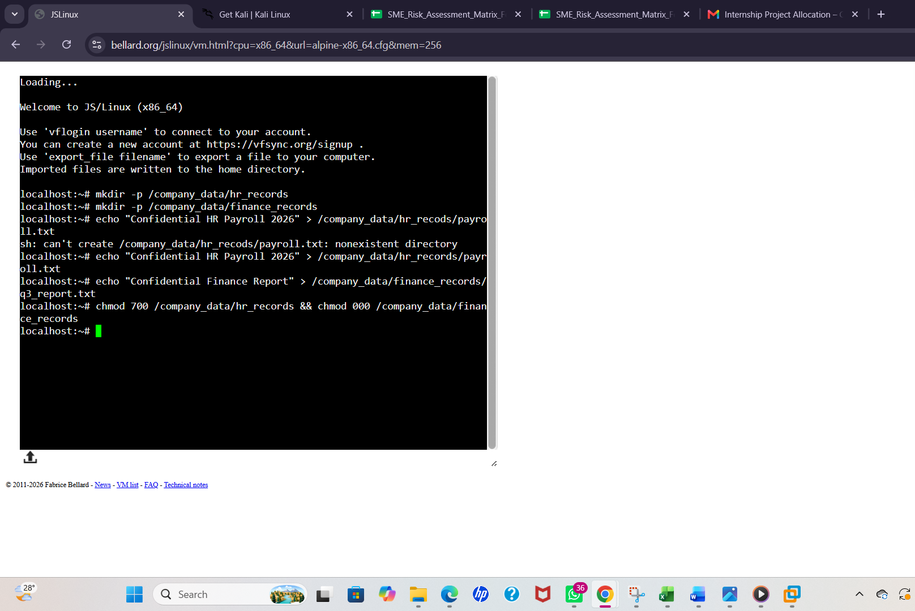

5. Threat Simulation & Security Testing
To test the effectiveness of the Zero Trust policies, two security scenarios were simulated representing authorized internal access and an unauthorized threat actor attempt.
Test Scenario A: Authorized Role Access (HR Department)
An authorized user role attempts to access records within their permitted departmental scope.
- Command Executed:
cat /company_data/hr_records/payroll.txt
- Result / Output Obtained:
Confidential HR Payroll 2026
- Analysis: Access granted successfully as permitted by the RBAC framework.
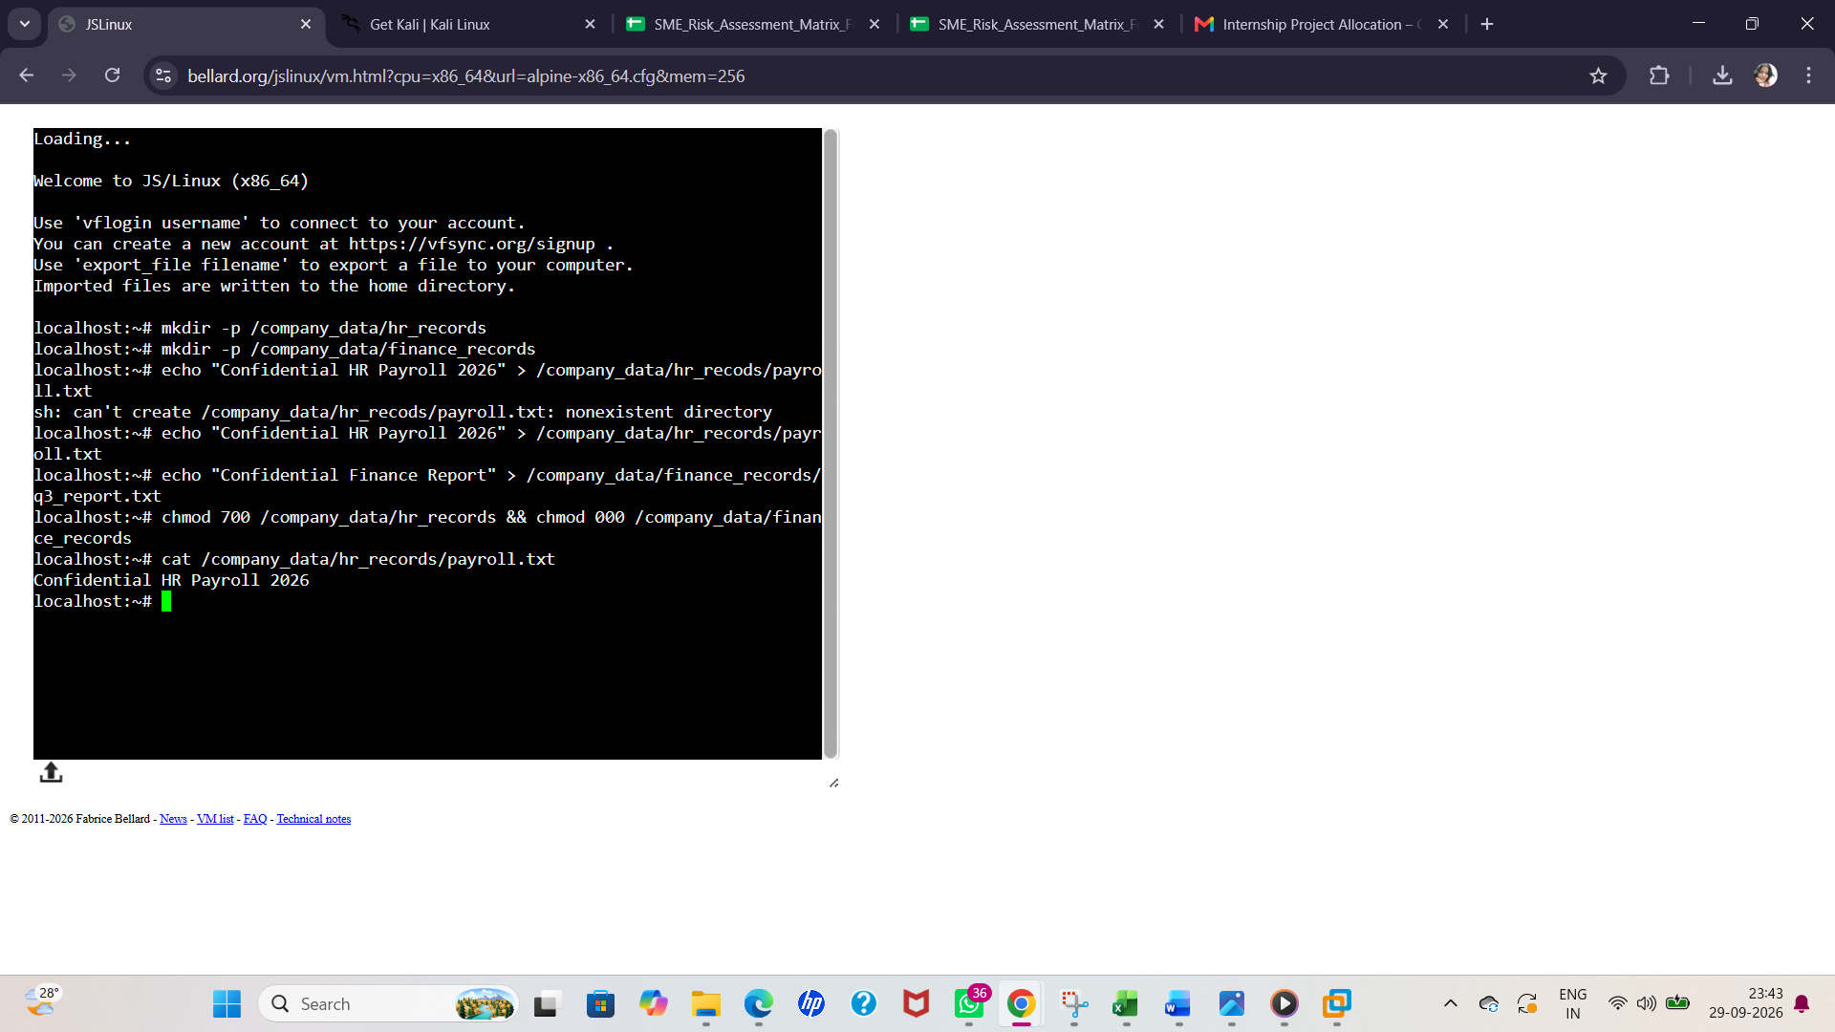

Test Scenario B: Unauthorized Threat Simulation (Insider / External Threat)
A non-privileged account (testuser) attempts to access restricted financial records (q3_report.txt) locked under zero-permission rules (chmod 000).
- User Switching Command:
adduser -D testuser && su testuser

- Unauthorized Access Command:
cat /company_data/finance_records/q3_report.txt
- Result / Output Obtained:
cat: can't open '/company_data/finance_records/q3_report.txt': Permission denied
- Analysis: The Zero Trust policy successfully blocked the unauthorized access attempt, containing the threat boundary.
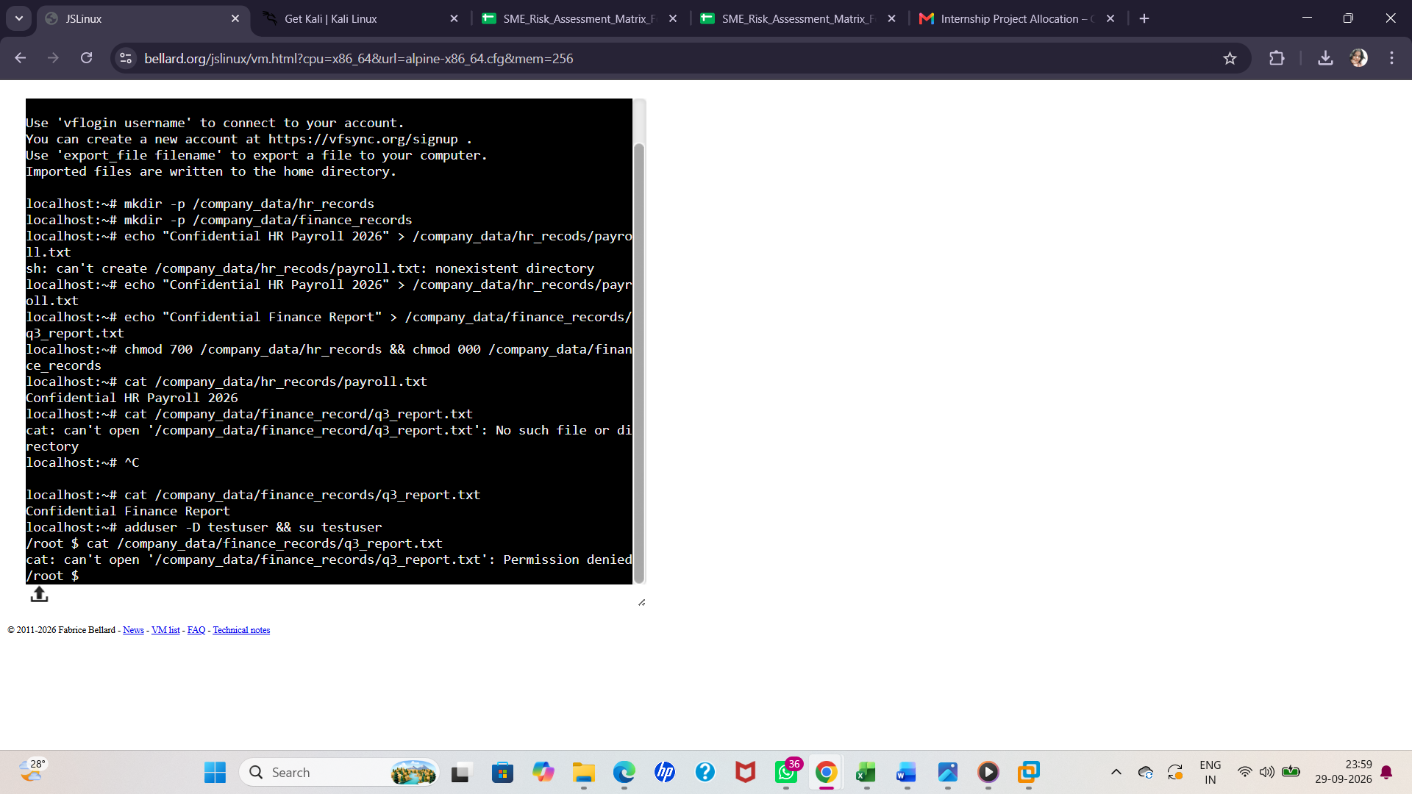

6. Documented Results & Suggested Improvements
Results Summary
The empirical testing validated that Zero Trust principles can effectively be enforced at the file system and access control level. By removing implicit administrative privileges (root) and testing under an unprivileged user role (testuser), micro-segmentation successfully prevented data exposure.
Suggested Improvements for Enterprise Deployment
- Automated Continuous Monitoring: Implement SIEM (Security Information and Event Management) tools like Splunk or Elastic Security to log and alert on Permission denied events in real-time.

- Centralized Identity & Access Management: Integrate Directory Services (Active Directory, Okta, or Keycloak) to manage identity lifecycles and dynamically automate role assignment.

- At-Rest & In-Transit Encryption: Implement robust storage encryption algorithms (AES-256) alongside Network Micro-Segmentation (VLANs, software-defined firewalls) to protect data across all states.

- Zero Trust Network Access (ZTNA): Replace traditional VPNs with ZTNA solutions that continuously evaluate context (device compliance, location, IP risk score) before granting access to enterprise endpoints.

7. Conclusion
The implementation of Minor Project - 2 successfully demonstrated the core tenets of Zero Trust Architecture. By combining identity verification, Role-Based Access Control, and micro-segmentation, unauthorized access attempts were blocked immediately (Permission denied). This confirms that explicit verification and least-privilege enforcement effectively eliminate implicit trust and secure sensitive enterprise assets.

